Dương Chí Khang – 1822040036

Bài 1:

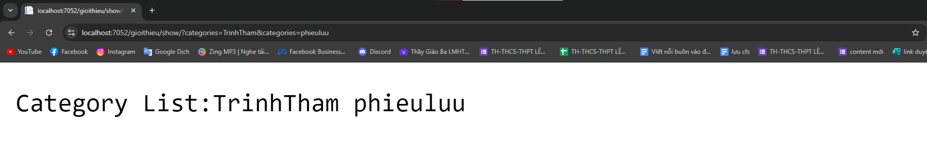

public IActionResult Show(List<string> categories)

{

string content = "Category List:";

foreach (var category in categories)

{

content += category + " ";

}

return Content(content);

}

Bài 2:

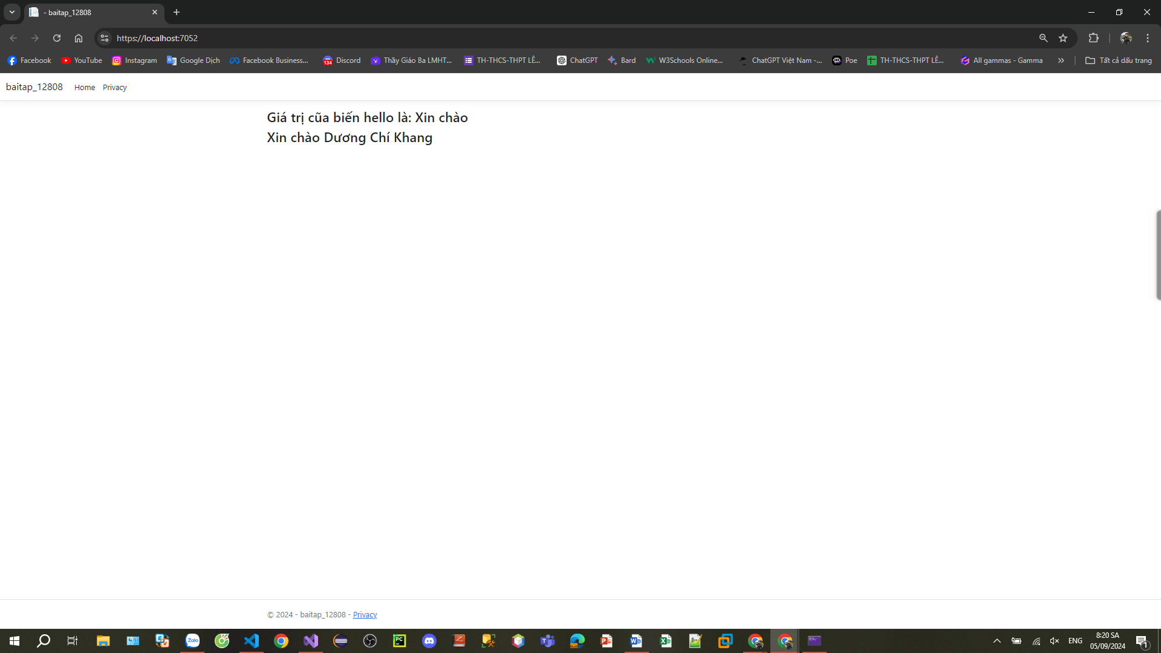

@\*Khối lệnh đơn \*@

@{

var hello = "Xin chào";

}

@\*Biểu thức nội tuyến\*@

<h3>Giá trị cũa biến hello là: @hello</h3>

@\*Khối nhiều dòng lệnh \*@

@{

var input = "Dương Chí Khang";

var output = hello + " " + input;

<h3>@output</h3>

}

Bài 3:

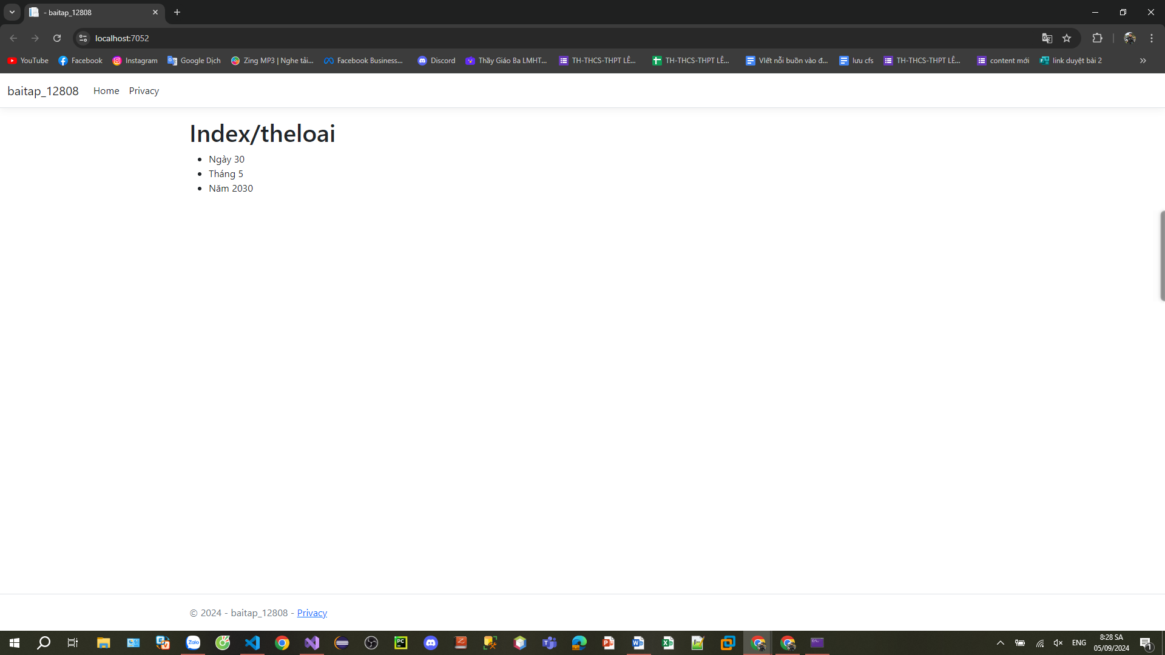

Controller

public IActionResult Index()

{

ViewBag.Ngay = "Ngày 30";

ViewBag.Thang = "Tháng 5";

ViewData["Nam"] = "Năm 2030";

return View();

}

Index

<h1>Index/theloai</h1>

<ul>

<li>@ViewBag.Ngay</li>

<li>@ViewBag.Thang</li>

<li>@ViewData["Nam"]</li>

</ul>

Bài 4 :

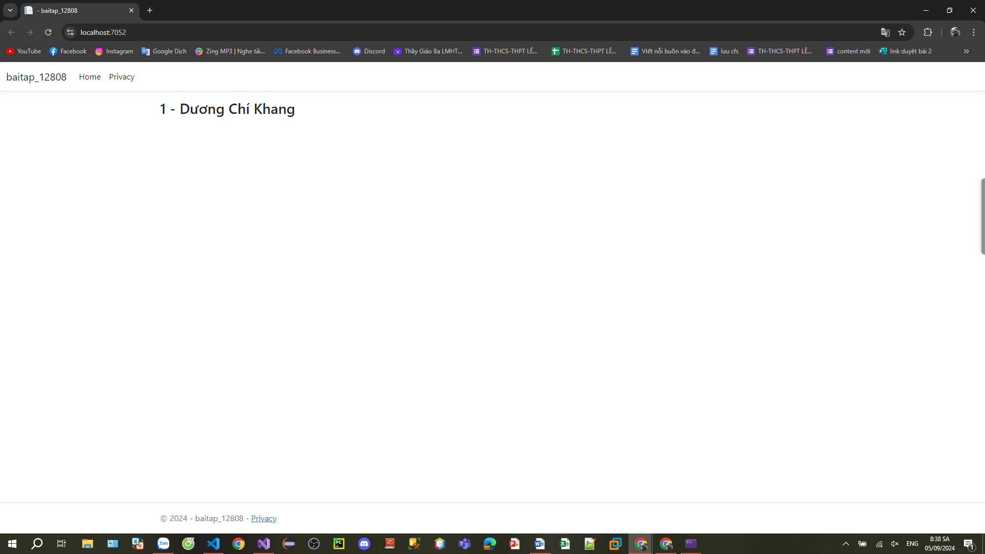

Controller

public IActionResult index1()

{

var theloai = new Class

{

Id = 1,

Name = "Dương Chí Khang"

};

return View(theloai);

}

Index

<h3>@Model.Id - @Model.Name</h3>

Bài tập thực hành:

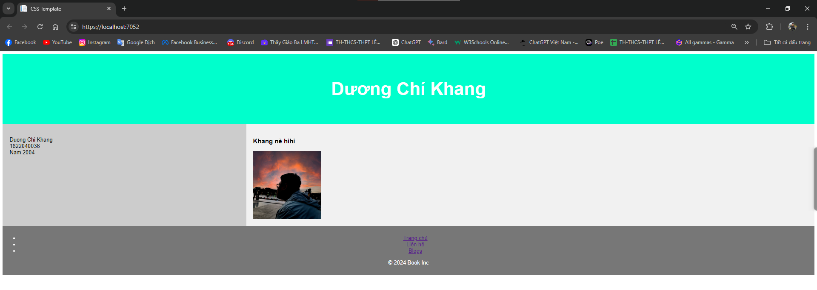

Index:

Layout = "";

<!DOCTYPE html>

<html lang="en">

<head>

<title>CSS Template</title>

<meta charset="utf-8">

<meta name="viewport" content="width=device-width, initial-scale=1">

<style>

\* {

box-sizing: border-box;

}

body {

font-family: Arial, Helvetica, sans-serif;

}

/\* Style the header \*/

header {

background-color: #00FFCC;

padding: 30px;

text-align: center;

font-size: 35px;

color: white;

}

/\* Create two columns/boxes that floats next to each other \*/

nav {

float: left;

width: 30%;

height: 300px; /\* only for demonstration, should be removed \*/

background: #ccc;

padding: 20px;

}

/\* Style the list inside the menu \*/

nav ul {

list-style-type: none;

padding: 0;

}

article {

float: left;

padding: 20px;

width: 70%;

background-color: #f1f1f1;

height: 300px; /\* only for demonstration, should be removed \*/

}

/\* Clear floats after the columns \*/

section::after {

content: "";

display: table;

clear: both;

}

/\* Style the footer \*/

footer {

background-color: #777;

padding: 10px;

text-align: center;

color: white;

}

/\* Responsive layout - makes the two columns/boxes stack on top of each other instead of next to each other, on small screens \*/

@@media (max-width: 600px) {

nav, article {

width: 100%;

height: auto;

}

}

</style>

</head>

<body>

<header>

<h2>Dương Chí Khang <h2>

</header>

<section>

<nav>

<ul>

<li>@ViewBag.Ten</li>

<li>@ViewBag.MSSV</li>

<li>@ViewData["Nam"]</li>

</ul>

</nav>

<article>

<h1>Khang nè hihi </h1>

<img src="https://localhost:7052/img/h2.png" alt="It me " style="max-width: 100%; height: 200px;" />

</article>

</section>

<footer class="footer">

<ul class="footer-nav">

<li class="nav-item"><a href="#" class="nav-link">Trang chủ</a></li>

<li class="nav-item"><a href="#" class="nav-link">Liên hệ</a></li>

<li class="nav-item"><a href="#" class="nav-link">Blogs</a></li>

</ul>

<p>© 2024 Book Inc</p>

</footer>

</body>

</html>

Controller:

public IActionResult Index1()

{

ViewBag.Ten = "Duong Chi Khang";

ViewBag.MSSV = "1822040036";

ViewData["Nam"] = "Nam 2004";

return View();

}